**Kind:** Assignment 2

**Team Size:** 1

**Hand-in:** Week 41 (October 13, 2016), end of session

**Task Code: SLTF**

# Preamble

In this assignment, you work individually. The main topics of this assignment are:

* Software Development
* Software Test, in particular: Test-First Development

In this task, you will have to develop a software solution and have to provide proper test environment. The task is time-boxed, and it is not expected that you provide a 100% solution. Do as much as you can. **BUT:** Regardless of the amount of work you manage in the given time, you have to submit a solution that compiles!

**Expected Deliverables:**

Your submission to Blackboard consists of a single zip file containing your solution:

* Naming: [no]-[login]-SLTF.zip

[no] means the number you have drawn, [login] means your BB login/e-mail name, such that we can find you on BB (just in case), for example: “33-mylogin-SLTF.zip”. It is essential that you follow this naming schema.

**Tip:**

In the Visual Studio environment, go to the “View” menu, and select “Task List”. The respective dialog helps you navigating the code in the solution scaffold.

**Task Code: SLTF**

**In order to pass this assignment, the delivery must be complete in terms of the code must compile! Further detailed instructions are in the task description.**

**After the submission of your file, don’t leave the room. There will be another questionnaire to answer. You can leave when the solution was shipped and the questionnaire is done.**

# Implement the Bowling Score Keeper

The objective is to develop an application that can calculate the score of a single bowling game. There is no graphical user interface. You work only with objects and NUnit test cases in this assignment. You won’t need a main method.

# Detailed Setup and Project Description

## Project Template

You are provided with a project template that contains three classes: Frame, BowlingGame and BowlingException. The template contains some fields and methods. You may add additional fields and methods. However, **DO NOT CHANGE** the names of the existing fields and methods. Also, the parameters and the return types of the methods in the template **SHOULD NOT BE CHANGED**.

Your program should throw BowlingException in all error situations.

You should follow *Test-First Development* method as shown in the following diagram:

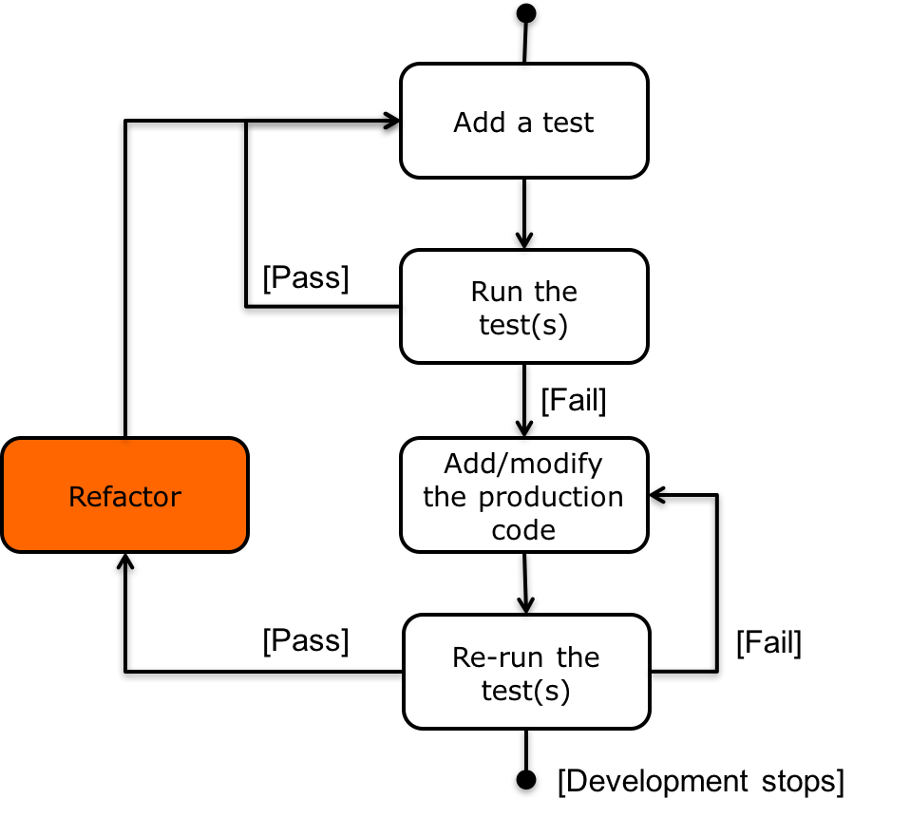

Figure 1 Test-First Development

## Game Description

The application’s requirements are divided into a set of user stories, which serve as your todo list. You should be able to incrementally develop a complete solution without an upfront comprehension of all the game’s rules. Don’t read ahead, and handle the requirements one at a time in the order provided. Only when a story is done, move on to the next one. A story is done when you are confident your program correctly implements all the functionality stipulated by the story’s requirement. This implies all of your test cases for that story and all of the test cases for the previous stories pass. You may need to tweak your solution as you progress towards more advanced requirements.

**1. Frame**

Each turn of a bowling game is called a frame. 10 pins are arranged in each frame. The goal of the player is to knock down as many pins as possible in each frame. The player has two chances, or throws, to do so. The value of a throw is given by the number of pins knocked down in that throw.

**Requirement**: Define a frame as composed of two throws. The first and second throws should be distinguishable.

**Example:** [2, 4] is a frame with two throws, in which two pins were knocked down in the first throw and four pins were knocked down in the second.

**2. Frame Score**

An ordinary frame’s score is the sum of its throws.

**Requirement:** Compute the score of an ordinary frame.

**Examples:** The score of the frame [2, 6] is 8. The score of the frame [0, 9] is 9.

**3. Game**

A single game consists of 10 frames.

**Requirement:** Define a game, which consists of 10 frames.

**Example:** The sequence of frames [1, 5] [3, 6] [7, 2] [3, 6] [4, 4] [5, 3] [3, 3] [4, 5] [8, 1] [2, 6] represents a game. This game will be used in examples from now on to represent different scenarios, modifying only a few frames each time.

**4. Game Score**

The score of a bowling game is the sum of the individual scores of its frames.

**Requirement:** Compute the score of a game.

**Example:** The score of the game [1, 5] [3, 6] [7, 2] [3, 6] [4, 4] [5, 3] [3, 3] [4, 5] [8, 1] [2, 6] is 81.

**5. Strike**

A frame is called a strike if all 10 pins are knocked down in the first throw. In this case, there is no second throw. A strike frame can be written as [10, 0]. The score of a strike equals 10 plus the sum of the next two throws of the subsequent frame.

**Requirement:** Recognize a strike frame. Compute the score of a strike. Compute the score of a game containing a strike.

**Examples:** Suppose [10, 0] and [3, 6] are consecutive frames. Then the first frame is a strike and its score equals 10 + 3 + 6 = 19. The game [10, 0] [3, 6] [7, 2] [3, 6] [4, 4] [5, 3] [3, 3] [4, 5] [8, 1] [2, 6] has a score of 94.

**6. Spare**

A frame is called a spare when all 10 pins are knocked down in two throws. The score of a spare frame is 10 plus the value of the first throw from the subsequent frame.

**Requirement:** Recognize a spare frame. Compute the score of a spare. Compute the score of a game containing a spare frame.

**Examples:** [1, 9], [4, 6], [7, 3] are all spares. If you have two frames [1, 9] and [3, 6] in a row, the spare frame’s score is 10 + 3 = 13. The game [1, 9] [3, 6] [7, 2] [3, 6] [4, 4] [5, 3] [3, 3] [4, 5] [8, 1] [2, 6] has a score of 88.

**7. Strike and Spare**

A strike can be followed by a spare. The strike’s score is not affected when this happens.

**Requirement:** Compute the score of a strike when it’s followed by a spare. Compute the score of a game with a spare following a strike.

**Examples:** In the sequence [10, 0] [4, 6] [7, 2], a strike is followed by a spare. In this case, the score of the strike is 10 + 4 + 6 = 20, and the score of the spare is 4 + 6 + 7 = 17. The game [10, 0] [4, 6] [7, 2] [3, 6] [4, 4] [5, 3] [3, 3] [4, 5] [8, 1] [2, 6] has a score of 103.

**8. Multiple Strikes**

Two strikes in a row are possible. You must take care when this happens for the computation of the first strike’s score requires the values of throws from two subsequent frames.

**Requirement:** Compute the score of a strike that is followed by another strike. Compute the score of a game with two strikes in a row.

**Examples:** In the sequence [10, 0] [10, 0] [7, 2], the score of the first strike is 10 + 10 + 7 = 27. The score of the second strike is 10 + 7 + 2 = 19. The game [10, 0] [10, 0] [7, 2] [3, 6] [4, 4] [5, 3] [3, 3] [4, 5] [8, 1] [2, 6] has a score of 112.

**9. Multiple Spares**

Two spares in a row are possible. The first spare’s score is not affected when this happens.

**Requirement:** Compute the score of a game with two spares in a row.

**Example:** The game [8, 2] [5, 5] [7, 2] [3, 6] [4, 4] [5, 3] [3, 3] [4, 5] [8, 1] [2, 6] has a score of 98.

**10. Spare as the Last Frame**

When a game’s last frame is a spare, the player will be given a bonus throw. However, this bonus throw does not belong to a regular frame. It is only used to calculate the score of the last spare.

**Requirement:** Compute the score of a spare when it’s the last frame of a game. Compute the score of a game when its last frame is a spare.

**Example:** The last frame in the game [1, 5] [3, 6] [7, 2] [3, 6] [4, 4] [5, 3] [3, 3] [4, 5] [8, 1] [2, 8] is a spare. If the bonus throw is [7], the last frame has a score of 2 + 8 + 7 = 17. The game has a score of 90.

**11. Strike as the Last Frame**

When a game’s last frame is a strike, the player will be given two bonus throws. However, these two bonus throws do not belong to a regular frame. They are only used to calculate score of the last strike frame.

**Requirement:** Compute the score of a spare when it’s the last frame of a game. Compute the score of a game when the last frame is a strike.

**Example:** The last frame in the game [1, 5] [3, 6] [7, 2] [3, 6] [4, 4] [5, 3] [3, 3] [4, 5] [8, 1] [10, 0] is a strike. If the bonus throws are [7, 2], the last frame’s score is 10 + 7 + 2 = 19. The game’s score is 92.

**12. Bonus is a Strike**

Further bonus throws are not granted when a game’s last frame is a spare and the bonus throw is a strike.

**Requirement:** Compute the score of a game in which the last frame is a spare and the bonus throw is a strike.

**Example:** In the game [1, 5] [3, 6] [7, 2] [3, 6] [4, 4] [5, 3] [3, 3] [4, 5] [8, 1] [2, 8], the last frame is a spare. If the bonus throw is [10], the game’s score is 93.

**13. Best Score**

A perfect game consists of all strikes (a total of 12 of them including the bonus throws), and has a score of 300.

**Requirement:** Check that the score of a perfect game is 300.

**Example:** A perfect game looks like [10, 0] [10, 0] [10, 0] [10, 0] [10, 0] [10, 0] [10, 0] [10, 0] [10, 0] [10, 0] with bonus throws [10, 10]. It’s score is 300.

**14. Real Game**

**Requirement:** Check that the score of the game [6, 3] [7, 1] [8, 2] [7, 2] [10, 0] [6, 2] [7, 3] [10, 0] [8, 0] [7, 3] [10] is 135.